1. A square prism of 30 mm side and 90 mm height is lying on its base on HP such that the edges of the base are equally inclined to VP. The prism is cut by a section plane passing through the mid-point of the axis such that the true shape of the section is a rhombus of larger diagonal of 70 mm. Draw the sectional top view, true shape of the section.

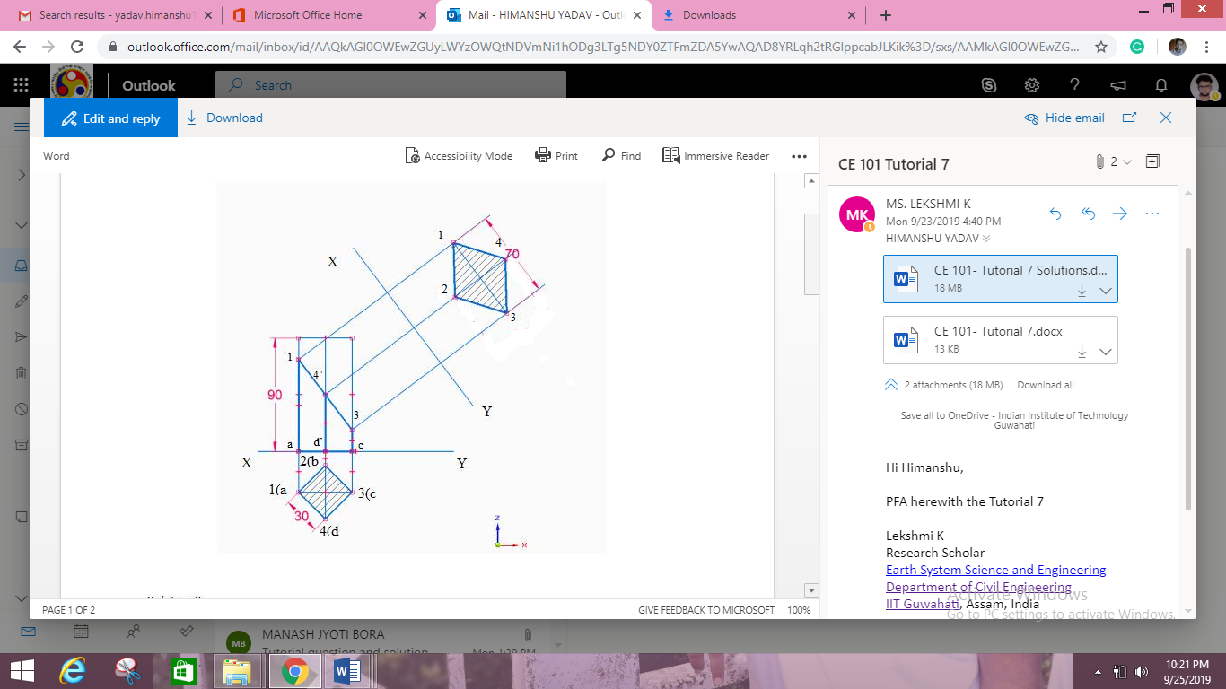

1. A cube of 50 mm side rests with one of its edges on HP such that square faces containing that edge are making equal inclination with HP. A horizontal section plane cuts at a distance of 18 mm below the horizontal edge nearer to the observer. Obtain front and sectional top views.

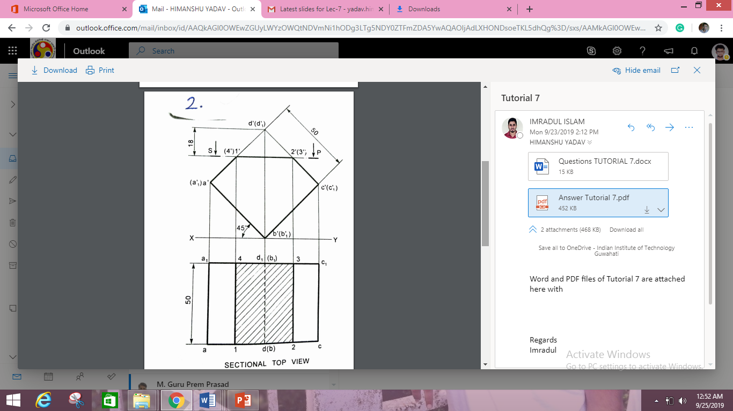

1. A cylinder of 40 mm diameter, 60 mm height and having its axis vertical is cut by a section plane, perpendicular to the VP, inclined at 45⁰ to the HP and intersecting the axis 32 mm above the base. Draw its front view, sectional top view, sectional side view and the true shape of the section.

